Week I

- Define data and its importance

- Define data analytics and its types

- Explain why analytics is important in today’s business environment

- Explain how statistics, analytics and data science are interrelated

- Why python?

- Explain the four different levels of Data: 7.Define Variable, Measurement and Data
8. Explain Data analytics vs. Data analysis 9.Give classification of Data Analytics 10.Give different Types of Variables.
- Give the usage Potential of Various Levels of Data.

- Explain following methods:

Head(),Get the number of rows and columns

get column names, get the dtype of each column get more information about data
Subset Rows by Index Label: loc get the first row
get the last row Subsetting Multiple Rows
Subset Rows by Row Number: iloc Subsetting Columns
Subsetting Columns by Range Subsetting Rows and Columns Subsetting Multiple Rows and Columns Calculating Grouped Means

Grouped Frequency Counts

- Explain Pandas Types Versus Python Types

- Give various methods of Visual Representation of the Data. 15 Give Measures of Central Tendency
16 How to calculate mean ,mode and median of ungrouped and grouped data? 17.Give the Measures of Variability or dispersion.
18. Define Common Measures of Variability

- Range

- Inter-quartile range

- Mean Absolute Deviation

- Variance

- Standard Deviation

- Z scores

- Coefficient of Variation 19What are Measures of Shape?

Week II 1)What is probability? What is range of probability?
2)What are Methods of Assigning Probabilities? 3)Define the following:
Probability - Terminology

- Experiment

- Event

- Elementary Events

- Sample Space

- Unions and Intersections

- Mutually Exclusive Events

- Independent Events

- Collectively Exhaustive Events

- Complementary Events

4)What do you mean by Sample Space? what are different Methods for describing a sample space? 5)Problem on Sampling from a Population with Replacement
- A tray contains 1,000 individual tax returns. If 3 returns are randomly selected with replacement from the tray, how many possible samples are there?
- (N)n = (1,000)3 = 1,000,000,000

- A tray contains 1,000 individual tax returns. If 3 returns are randomly selected without replacement from the tray, how many possible samples are there?
- Give four types of probability.: Marginal, joint,union, conditional 8)Give the general law of addition.
- Problem:• If one of the survey respondents was randomly selected and asked what office design changes would increase worker productivity, what is the probability that this person would select reducing noise or more storage space?

Solution

- Let N represent the event “reducing noise.”

- Let S represent the event “more storage/ filing space.”

- The probability of a person responding with N or S can be symbolized statistically as a union probability by using the law of addition.

- Give Law of Multiplication.

- Law of Conditional Probability

- The conditional probability of X given Y is the joint probability of X and Y divided by the marginal probability of Y.
- What is distribution?

- The quiz scores for a particular student are given below: 22, 25, 20, 18, 12, 20, 24, 20, 20, 25, 24, 25, 18
Find the variance and standard deviation. 14)Define covariance and correlation coefficient.
- The weight of football players is normally distributed with a mean of 200 pounds and a standard deviation of 25 pounds.What is the probability of a player weighing more than 241.25 pounds? Also calculate theprobability of a player weighing less than 250 pounds .

- Assuming a binomial experiment with p = 0.5 and a sample size of 100. What is the expected value of this distribution ?

Week 3

- Describe a simple random sample and why sampling is important

- Explain the difference between descriptive and inferential statistics

- Define the concept of a sampling distribution and give the types of sampling distributions

- Determine the mean and standard deviation for the sampling distribution of the sample mean,

- Describe the Central Limit Theorem and its importance

- Differentiate between sample and population

- Why one should go for sampling?

- Differentiate Random and Nonrandom Sampling.

- List and explain various Random Sampling Techniques

- List and explain various non-random Sampling Techniques.

- Suppose a large population has mean µ = 8 and standard deviation σ = 3.Suppose a random sample of size n = 36 is selected. What is the probability that the sample mean is between 7.8 and 8.2?

- If the true proportion of voters who support Proposition A is P = .4, what is the probability that a sample of size 200 yields a sample proportion between .40 and .45?

- Distinguish between a point estimate and a confidence interval estimate.
14)
A sample of 11 circuits from a large normal population has a mean resistance of 2.20 ohms. We know
from past testing that the population standard deviation is 0.35 ohms. Determine a 95% confidence interval for the true mean resistance of the population.

- A random sample of n = 25 has x = 50 and s = 8. Form a 95% confidence interval for µ using t test statistic.

- A random sample of 100 people shows that 25 are left-handed. Form a 95% confidence interval for the true proportion of left-handers.

- If the true proportion of customers who are below 20 years is P=0.35, what is the probability that a sample size of 100 yields a sample proportion between 0.3 to 0.4.

- Calculate the probability of getting 12 heads in 20 attempts from a fair coin.

- A question paper contains 90 multiple-choice questions. Each correct answer carries 1 mark. There are 4 alternative answers (A, B, C or D), of which only one is correct. Mr X answers these questions randomly (i.e. without preparation). What is the probability that X gets at least 10 marks?

- On average, 5 % of items supplied by manufacturer X are defective. If a batch of 10 items is inspected: what is the probability that 2 items are defective.

- A car distributor in City Y experiences an average of 2.5 car sales daily. Find the probability that on a randomly selected day

- , they will sell 5 car:

- they will sell no cars

- they will sell at most 2 cars

- they will sell exactly one car

Week IV

  - What is Hypothesis Testing? Define Null hypothesis and Alternate hypothesis
  - Differentiate between type I and type II error.
  - Give the three Approaches for Hypothesis Testing.
  - What are the steps of Hypothesis Testing using P value approach.
  - What are the steps of Hypothesis Testing using critical value approach.
  - The quality-control manager at a Li-BATTERY factory needs to determine whether the mean life of a large shipment of Li-Battery is equal to the specified value of 375 hours. The process standard deviation is known to be 100 hours. A random sample of 64 batteries indicates a sample mean life of 350 hours. State the null hypotheses.
  - In question 6, At the alpha = 0.05 level of significance, is there any evidence that the mean life differs from 375 hours
  - In question 6, compute the p-value ?
  - In question 6, at a 95% confidence interval, calculate the estimate of the population mean life of the battery.
  - The mean cost of a hotel room in a city is $168 per night. A random sample of 25 hotels resulted in X-bar = $172.50 and sample standard deviation s = 15.40. Calculate the t statistic.
  - At the α = 0.05 level. In question 10, what is the decision on the null hypothesis ?

Week V

- What is Analysis of Variance (ANOVA)?

- How does one set the hypothesis for ANOVA?

- What do you mean by one-way ANOVA?

- In a problem of ANOVA involving 3 treatments and 10 observations per treatment, SSE = 399.6.Calculate the MSE for this situation .
- In an ANOVA problem if SST = 120 and SSTR = 80, what is the value of SSE ?

- Calculate the critical F value with 8 numerator and 29 denominator degrees of freedom at alpha = 0.01 .

7) Mean marks obtained by male and female students of schools ABCD in the first unit test are shown
below.
 | Male | Female
Sample Size | 64 | 36
Sample Mean Marks | 44 | 41
Population Variance () | 128 | 72

What is the standard error for the difference between the two means ?

WEEK 6

  - What do you mean by two way Anova?

  - What is regression analysis?

  - Give Simple Linear Regression Model.

  - Give Simple Linear Regression Equation.

  - What is Estimated Simple Linear Regression Equation.

  - Explain the principle behind the least square method.

  - Explain the estimation process in linear regression.

  - Give the equation to find Slope and y-intercept for the Estimated Regression Equation i.e. b1

  - What is the coefficient of determination in linear regression?

  - Give the Relationship Among SST, SSR, SSE.

  - In regression analysis, which are the assumptions about the error term ε?

  - Which tests are used for a significant regression relationship,

  - For the given data determine the R-squared value

Miles travel | Petrol Consumption in litre
20 | 1
45 | 3
56 | 5

34 | 2
28 | 1.6
49 | 3.7

Week 7

- Define the terms:

  - Confidence interval,

  - Prediction interval

  - Point Estimate

- Differentiate between Confidence intervals vs prediction intervals

- What is residual analysis ? Explain different types of residual analysis

- What is standardized residuals?

- Explain the estimation process For multiple regression.

- Give the Multiple regression model

- Differentiate between Simple and multiple regression.

- Explain Multiple Coefficient of Determination and adjusted Multiple Coefficient of Determination and relation between two.

- Differentiate between Adjusted Multiple Coefficient and Multiple Coefficient.

- For a multiple regression model with 2 independent variables, R.sq = 0.904 and adjusted R. sq = 0.88, determine the number of observations (n)

- Explain F-test and t-test used in Multiple regression and compare the two.

- State how categorical variables are handled in regression analysis.

Week 8

- Explain Maximum Likelihood Estimation(MLE)

- What do you mean by logistic regression and explain when it is used.

- What is G test statistic used in logistic regression.?

- Compare Linear Regression model and Logistic regression model

- Give the Objectives of logistic regression.

- What is Log likelihood?

- Differentiate between Logistic regression and discriminant analysis.

- Explain the Normality of Residual (Error) in both linear and logistic regression.

- The logit function(given as l(x)) is the log of odds function. What could be the range of logit function in the domain x = [0,1]?

Week 9

- For the given confusion matrix, compute the recall

True Positive True Negative

Predicted Positive | 8 | 3
Predicted Negative | 2 | 7

- Define Sensitivity in ROC analysis

- Describe various Accuracy Measures for Classification.

- What is ROC?

- How to select a Threshold using ROC?

- Differentiate between Sensitivity and Specificity parameters for checking the type of error.

- 7)How to select Threshold value on ROC curve

- Give the First-order regression equation and second order linear model.

- Explain in detail the effect -Interaction of the independent variable to the regression model.

Week 10

- Describe the Chi-square test of independence.

- What are two main types of Chi-Square tests?

- What are limitations of Chi-Square Test?

- What is the difference between t-test and chi-square?

- What are the characteristics of chi-square?
- What do you mean by cluster analysis ? State its purpose.

- Differentiate between cluster analysis and discriminent analysis

- What are different types of data ? Why there is need to standardize data?

- Explain the effect of standardization using example.

- Give the metrics for computation of distances between the objects.

- Caculate the Euclidean distance and manhattan distance between points (2, -1) and (-2, 2)

Week 11

- Explain how to handle missing data in data set?

- Differentiate between symmetric and asymmetric binary variable.

- What do you mean by categorical variable ? how to find dissimilarity between categorical variables?
- What do you mean by ordinal variable ? how to find dissimilarity between ordinal variable?

- What is ratio-scaled variable?

- Explain three methods to handle ratio-scaled variables for computing dissimilarity between objects.
- Give the classification of clustering methods.

- Explain K-means clustering algorithm.

- Differentiate between partitioning and hierarchical clustering methods.

- Compare agglomerative and divisive hierarchical clustering methods.

- Give the measures for distance between clusters.

- What is dendogram?

- Differentiate between k-means and hierarchical clustering methods.

- What are the difficulties with hierarchical clustering?

- What are the limitations of hierarchical clustering?

- What is decision tree?

- What are various measures or linkage methods to calculate the distance between two clusters.

Week 12

- What is CART?

- Write decision tree algorithm.

- What are different attribute selection measures in decision tree?

- How does tree pruning work in decision tree?

- Calculate entropy for the following data and find out the root node of decision tree using information gain.
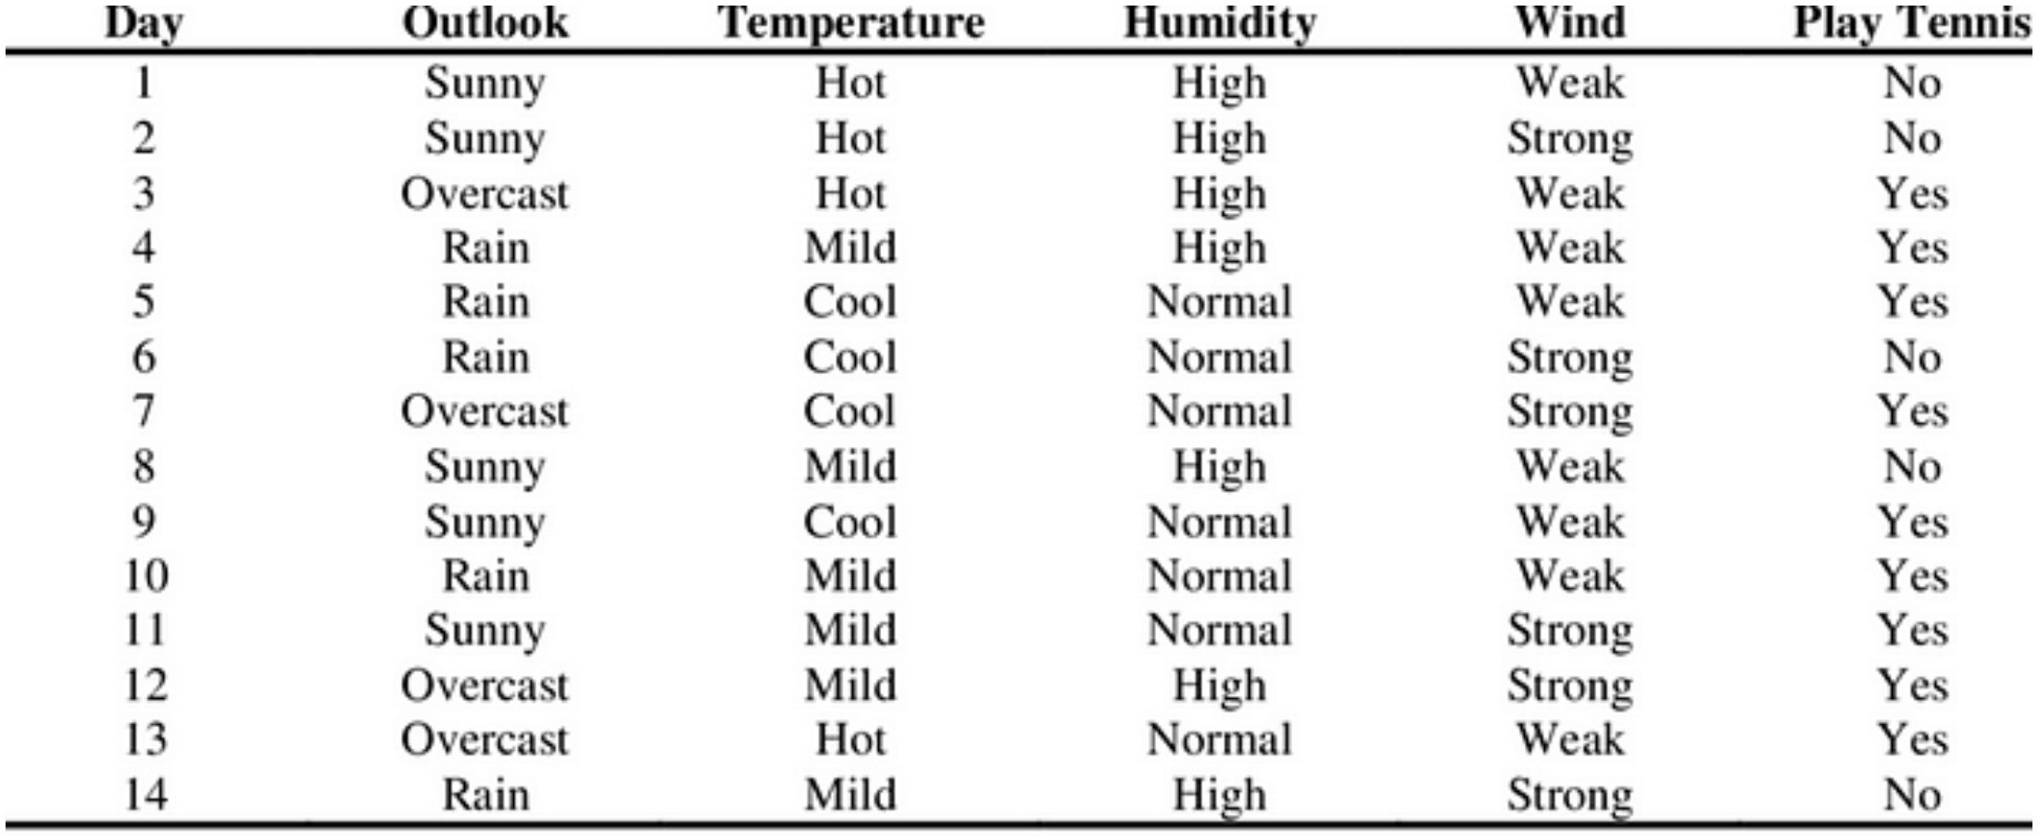

- What are different measures for attribute selection in decision tree?

- How does gain ratio differs from information gain?

